**VISVESVARAYA TECHNOLOGICAL UNIVERSITY**

**“JnanaSangama”, Belgaum -590014, Karnataka.**



**LAB REPORT on**

# Machine Learning

***Submitted by***

## HIMANI BM

## (1BM19CS062)

***in partial fulfillment for the award of the degree of***

**BACHELOR OF ENGINEERING**

***in***

## COMPUTER SCIENCE AND ENGINEERING



## B.M.S. COLLEGE OF ENGINEERING BENGALURU-560019 May-2022 to July-2022

**(Autonomous Institution under VTU)**

**B. M. S. College of Engineering,**

**Bull Temple Road, Bangalore 560019**

(Affiliated To Visvesvaraya Technological University, Belgaum)

### Department of Computer Science and Engineering



#### CERTIFICATE

This is to certify that the Lab work entitled “Machine Learning” carried out by **HIMANI BM (1BM19CS062),** who is bonafide student of **B. M. S. College of Engineering.** It is in partial fulfillment for the award of **Bachelor of Engineering in Computer Science and Engineering** of the Visvesvaraya Technological University, Belgaum during the year 2022. The Lab report has been approved as it satisfies the academic requirements in respect of a **Machine Learning - (20CS6PCMAL)** work prescribed for the said degree.

Dr G R Asha **Dr. Jyothi S Nayak**

Assistant Professor Professor and Head

Department of CSE Department of CSE

BMSCE, Bengaluru BMSCE, Bengaluru

`

## Index Sheet

| **Sl.**  **No.** | **Experiment Title** | **Page No.** |
| --- | --- | --- |
| **1** | **Find-S** |  |
| **2** | **Candidate Elimination** |  |
| **3** | **Decision Tree** |  |
| **4** | **Naïve Bayes** |  |
| **5** | **Linear Regression** |  |
|  |  |  |
|  |  |  |
|  |  |  |
|  |  |  |
|  |  |  |
|  |  |  |
|  |  |  |
|  |  |  |
|  |  |  |
|  |  |  |

**Course Outcome**

| CO1 | Ability to apply the different learning algorithms. |
| --- | --- |
| CO2 | Ability to analyze the learning techniques for given dataset |
| CO3 | Ability to design a model using machine learning to solve a problem. |
| CO4 | Ability to conduct practical experiments to solve problems using appropriate machine learning  Techniques. |

1. Implement and demonstrate the FIND-S algorithm for finding the most specific hypothesis based on a given set of training data samples.



1. For a given set of training data examples stored in a .CSV file, implement and demonstrate the Candidate-Elimination algorithm to output a description of the set of all hypotheses consistent with the training examples

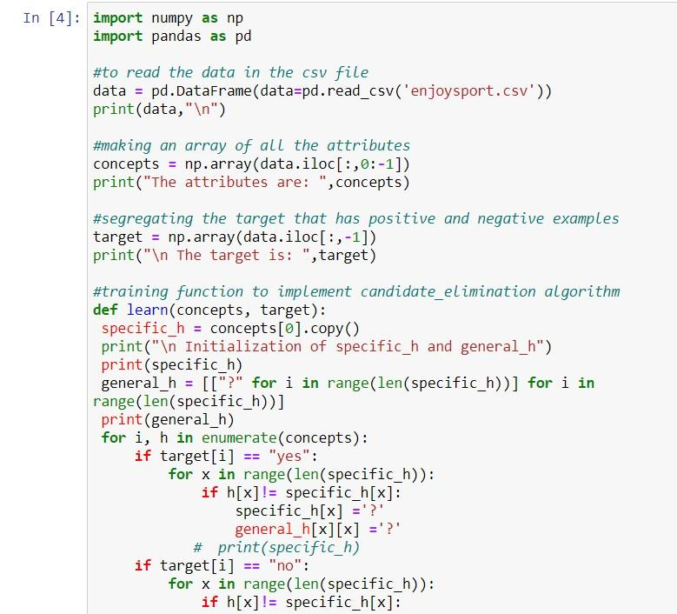



3)Write a program to demonstrate the working of the decision tree based ID3 algorithm. Use an appropriate data set for building the decision tree and apply this knowledge to classify a new sample.





4)Write a program to implement the naïve Bayesian classifier for a sample training data set stored as a .CSV file. Compute the accuracy of the classifier, considering few test data sets





5)Implement the Linear Regression algorithm in order to fit data points. Select appropriate data set for your experiment and draw graphs.



